**Data Engineering Assignment – 17**

**VISUALIZATION IN DATABRICKS:**

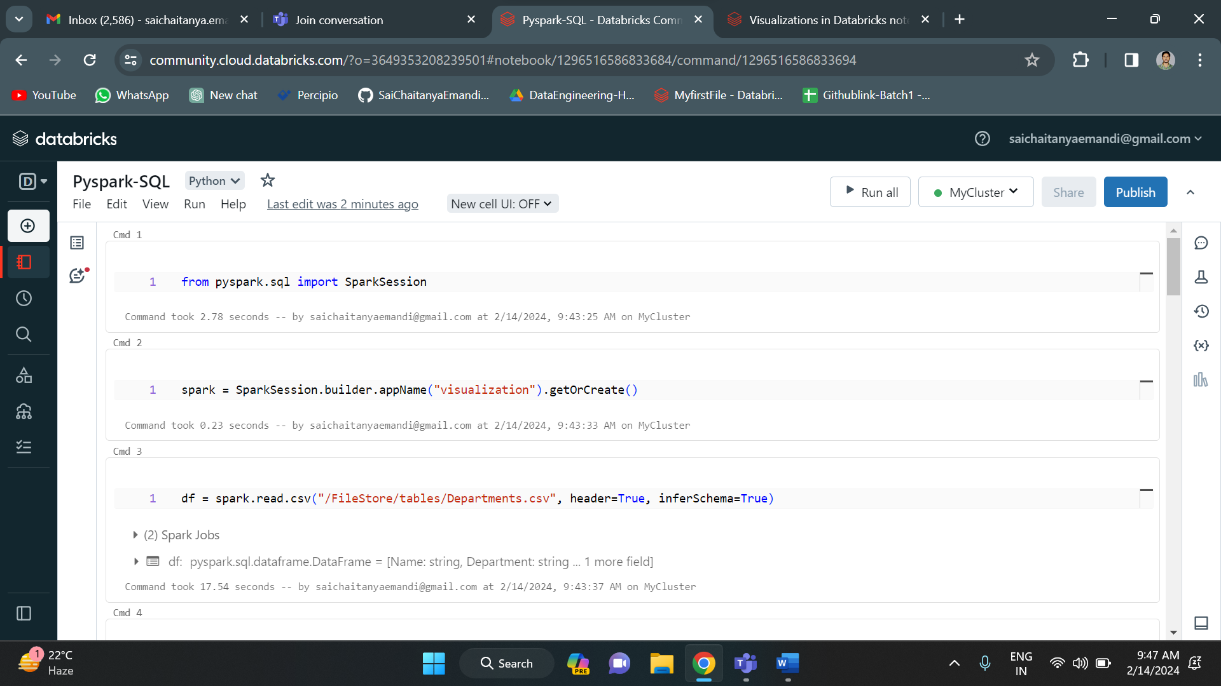

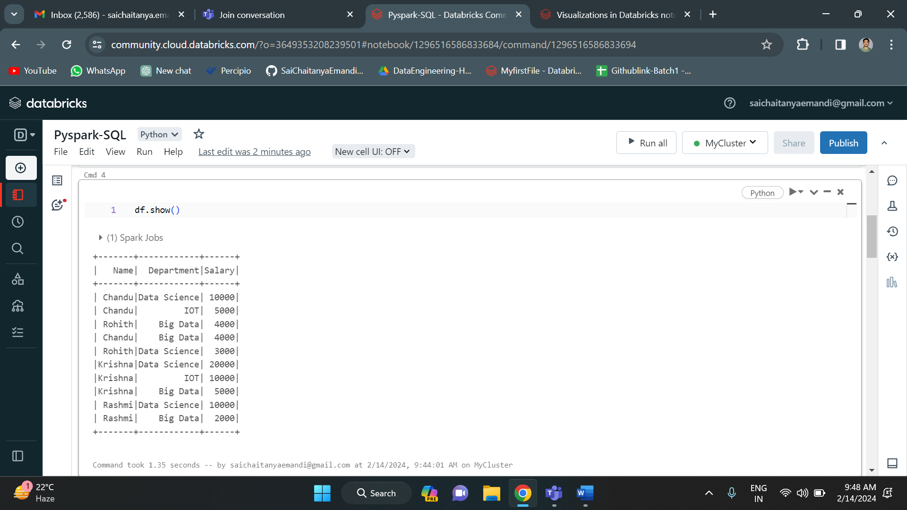

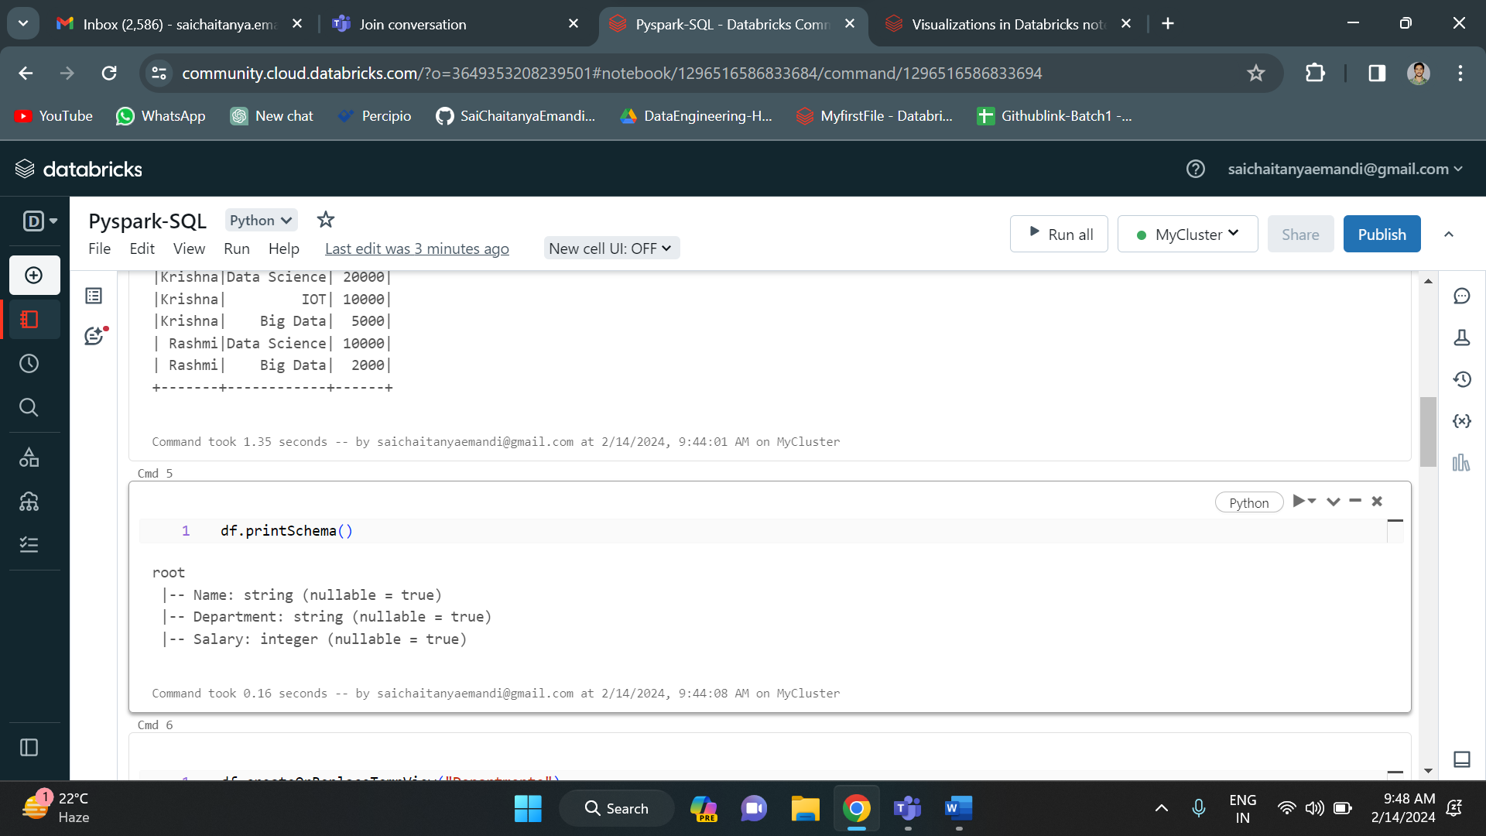

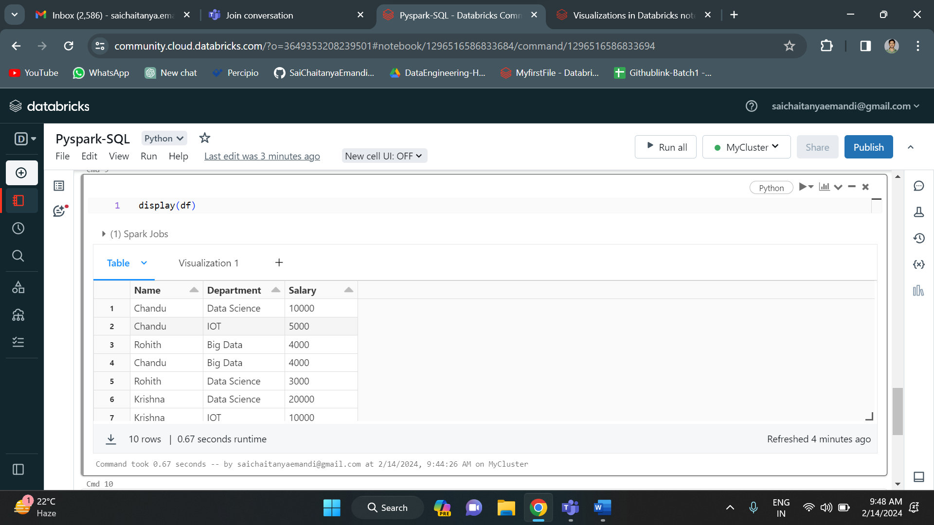

There is a “+” icon below. We need to press that and then there appears visualization option.

I have selected bar under visualization. And this is the output:

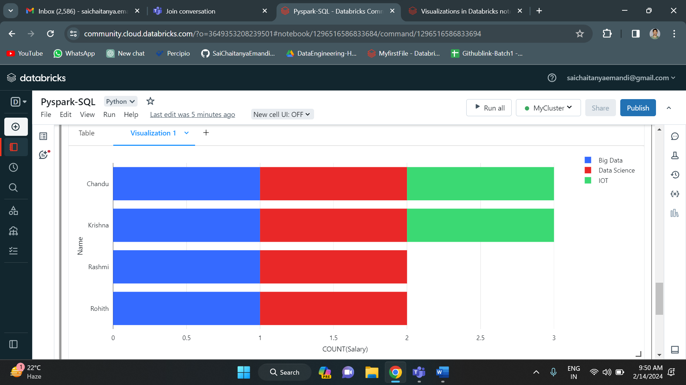

I have taken Salary on x-axis and Names on y-axis. And I have grouped the data on department.